EcoFlow Inc.
Plant A202, Founder Technology Industrial Park, Shiyan Sub-district, Bao’an District Shenzhen, Guangdong 518000 China

Alexis Hu, resident in China, as Product Manager of the EcoFlow, based in Shenzhen China, on behalf of the same Company declares the following:

The product includes a system of internal and external logic communications as summarized in the following scheme:

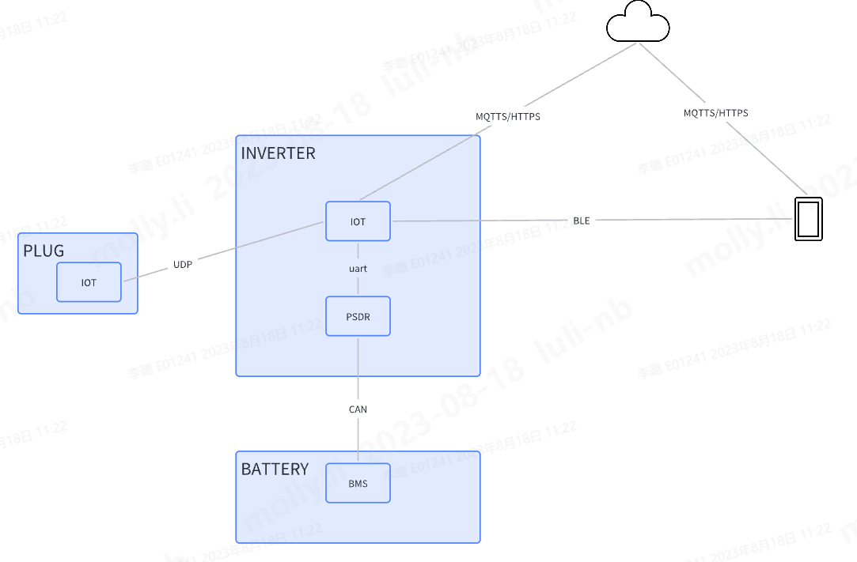
See below components involved and their main functions in the following table.

- Internal modules communication

There are two modules inside the micro inverse, namely PSDR module responsible for power management, IOT module for communication management, PSDR module and IOT module connected through physical serial ports.

- micro inverse and external module communication
- Micro inverse communicates with external battery pack through CAN interface, and AES encryption is used.
- Micro Inverse communicates with sockets in LAN through UDP, and AES encryption is used.
- Micro Inverse communicates with mobile phone through Bluetooth, and AES encryption is used.
- Micro Inverse communicates with the cloud server through WIFI, and the communication uses TLS encryption channel.

IOT | Wireless communication module, can communicate with other devices IOT module LAN, can also be through Bluetooth and Mobile APP communication, through WIFI and cloud server communication; Collect the energy data required by the socket and feed back to it
PSDR | Power management module
BMS | The battery management module monitors and manages the battery cells

EN 303 645 v2.1.1 (2020-06) Table B.1: Implementation of provisions foor consumer lot security
Clause number and title
Reference | Status | Support | Detail
5.1 No universal default passwords
Provision 5.1-1 | MC | Y
Provision 5.1-2 | MC | Y
Provision 5.1-3 | MC | Y
Provision 5.1-4 | MC | Y
Provision 5.1-5 | MC | Y
5.2 Implement a means to manage reports of vulnerabilities
Provision 5.2-1 | M | Y
Provision 5.2-2 | R | N
Provision 5.2-3 | R | N
5.3 Keep software updated
Provision 5.3-1 | R | N
Provision 5.3-2 | MC | Y
Provision 5.3-3 | MC | Y
Provision 5.3-4 | RC | N
Provision 5.3-5 | RC | N
Provision 5.3-6 | RC | N
Provision 5.3-7 | MC | Y
Provision 5.3-8 | MC | Y
Provision 5.3-9 | RC | N
Provision 5.3-10 | M | Y
Provision 5.3-11 | RC | N
Provision 5.3-12 | RC | N
Provision 5.3-13 | M | Y
Provision 5.3-14 | RC | N
Provision 5.3-15 | RC | N
Provision 5.3-16 | M | Y
5.4 Securely store sensitive security parameters
Provision 5.4-1 | M | Y
Provision 5.4-2 | MC | Y
Provision 5.4-3 | M | Y
Provision 5.4-4 | M | Y
5.5 Communicate securely
Provision 5.5-1 | M | Y
Provision 5.5-2 | R | N
Provision 5.5-3 | R | N
Provision 5.5-4 | R | N
Provision 5.5-5 | M | Y
Provision 5.5-6 | R | N
Provision 5.5-7 | M | Y
Provision 5.5-8 | M | Y
5.6 Minimize exposed attack surfaces
Provision 5.6-1 | M | Y
Provision 5.6-2 | M | Y
Provision 5.6-3 | R | N
Provision 5.6-4 | MC | Y
Provision 5.6-5 | R | N
Provision 5.6-6 | R | N
Provision 5.6-7 | R | N
Provision 5.6-8 | R | N
Provision 5.6-9 | R | N
5.7 Ensure software integrity
Provision 5.7-1 | R | N
Provision 5.7-2 | R | N
5.8 Ensure that personal data is secure
Provision 5.8-1 | R | N
Provision 5.8-2 | M | Y
Provision 5.8-3 | M | NA | No such device, not applicable
5.9 Make systems resilient to outages
Provision 5.9-1 | R | N
Provision 5.9-2 | R | N
Provision 5.9-3 | R | N
5.10 Examine system telemetry data
Provision 5.10-1 | RC | N
5.11 Make it easy for users to delete user data
Provision 5.11-1 | M | Y
Provision 5.11-2 | R | N
Provision 5.11-3 | R | N
Provision 5.11-4 | R | N
5.12 Make installation and maintenance of devices easy
Provision 5.12-1 | R | N
Provision 5.12-2 | R | N
Provision 5.12-3 | R | N
5.13 Validate input data
Provision 5.13-1 | M | Y
6 Data protection provisions for consumer IoT
Provision 6.1 | M | Y
Provision 6.2 | MC | Y
Provision 6.3 | M | Y
Provision 6.4 | RC | N
Provision 6.5 | MC | Y
Conditions
1) passwords are used;
2) pre-installed passwords are used;
3) software components are not updateable;
4) the device is constrained;
5) the device is not constrained;
6) telemetry data being collected;
7) personal data is processed on the basis of consumers' consent;
8) the device allowing user authentication;
9) the device supports automatic updates and/or update notifications;
10) a hard-coded unique per device identity is used for security purposes;
11) updates are delivered over a network interface;
12) an update mechanism is implemented;
13) a debug interface is physically accessible.
M | Mandatory provision
R | Recommended provision
M | Mandatory provision
R | Recommended provision
MC | Mandatory and conditional provision
RC | Recommended and conditional provision
Support' Column
Y | Implemented
N | Not implemented
N/A | Not applicable
Date: | 2023/12/15
Name: | Alexis Hu
Title: | Product Manager
Signature:

